LAMAR TRAFFIC PATTERN
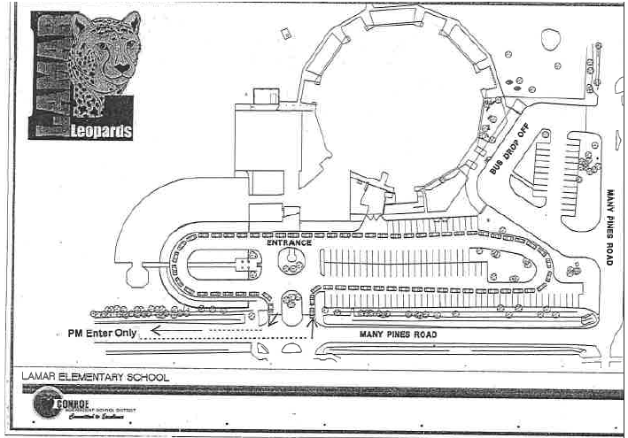

TRANSPORTATION TAGS
- Every student will be given a transportation tag that will be zip tied to their backpack. This tag will have a bar code that will be scanned everyday as they are dismissed from the building. This tag must remain on the student’s back pack for the entire year.

TRANSPORTATION – MORNING PROCEDURES
- Bikers and walkers: Bikers and walkers will cross the street at Deerfoot Circle with our crossing guard. Once they have crossed the street, they will follow the sidewalk turning left inside the brick wall. Bikers and walkers will continue on the sidewalk along the brick wall and enter the building through the door at the front office entrance. Students should NEVER cross over any driveways to get to a building entrance.
- Car riders: All car riders and day care van riders will enter the building through the doors at the front office entrance. For the safe flow of traffic, it is imperative that entering vehicles form one line. Drivers should proceed with caution when approaching the school to drop off children. For your child’s safety, children must get out of the car on the CURBSIDE. Please make adjustments in your car so your child can exit the car on the right side. Please do not drop off students before 7:30AM.
- Bus riders: Please remember that students are only allowed to ride their assigned bus. All buses load and unload from the bus area at the side of the building.

TRANSPORTATION – AFTERNOON PROCEDURES:
- Day Care: If your child is absent or not riding Day Care transportation, please notify the Day Care of the change. Day Care drivers must account for all children before leaving the school. If your child is riding a school bus to a designated Day Care, you must fill out a Bus Service Alternate Address Form. Otherwise, your child will be delivered to your home address. Your child’s Day Care should have provided you with this form or you can request one from our front office.
- Bus Riders: Bus stop information can be accessed through the CISD website. The Transportation Department website contains Bus arrival and departure times and valuable safety information which will help you teach your children about bus safety. Please note that we sometimes have to make route adjustments during the first few weeks of class due to changes in student and neighborhood populations. Pre-Kindergarten and Kindergarten students will not be dropped off at a stop unless a parent is present. If a student is placed on the wrong bus, the driver will contact us and bring the child back to school. It may take a while for the bus to return, as the driver may complete the route. Parents can help us by staying at home and calling us immediately when the child arrives. If the child is brought back to school, the school will contact the parents. After 4:00 PM, any concerns regarding bus transportation should be directed to the South County Transportation Center.
- Car Riders: Car riders will be picked up in the car lane that starts at the front of the school. Please remain in your car and wait for a school employee to assist your child. Please do not motion for your child to come to you and please do not walk up with the car sign to pick up your child. If you designated your child as a car rider, you need to remain in your car.
- Signs provided by the school must be displayed in the car’s front window. Signs will be available in the front office. The sign ensures that we are placing each child in the car of the person authorized to pick him/her up from school and will help to speed up the car rider line. If you do not have a sign, please allow enough time to obtain one from the Front Office and return to the car rider line to pick up your child. Children will not be placed in a car without the appropriate sign.
- Before pulling away, we want to make sure that every child is buckled in a seat belt. We want everyone to have a safe ride home.
- Bikers and Walkers: Bikers and walkers will be dismissed at 3:10 beginning the second week of school. The first week of school we start dismissal at 3:00. Children classified as a biker/walker must live in the neighborhoods near the school. If your child is a biker/walker and you are planning to meet him/her at the Lamar campus, please wait along the sidewalk inside the brick way or under the awning by the annex door. All bikers and walkers will exit the building at the annex door. Bikers dismiss first.
- Biker/Walker Signs provided by the school must be displayed by the person picking the child up. Signs will be available in the front office. If you do not have a sign, please allow enough time to obtain one from the Front Office (you will need your ID), then return to the dismissal area.
- The crossing guard will assist all bikers/walkers in crossing Many Pines. Parents will not be permitted to park and leave their vehicle on Many Pines, the school parking lot or in the Glen Mill subdivision to pick a child up. This creates safety concerns and traffic delays.
- We encourage the use of bike locks and helmets for those students who ride their bikes to school.
- On school days when we have severe weather in the afternoon, students who regularly walk, ride their bikes, or roller blade home from school can ride the bus home from school. We will generate a Severe Weather Day Bus List that will be sent to CISD Transportation to accommodate these students on severe weather days. All of these students must be registered for bus transportation.
- If your child is not to be placed on a bus, please send a note to the classroom teacher indicating the alternative transportation for each severe weather day.

Morning Pre-K Dismissal
- Dismissal will begin at 11:05. All students will be dismissed from the annex doors of the school. Cars will wait until all CISD buses are loaded and prepared to leave. Please remain in your car and wait for a school employee to assist your child. Please do not motion for your child to come to you.
- Signs provided by the school must be displayed in the car’s front window. Signs will be available in the front office. The sign ensures that we are placing each child in the car of the person authorized to pick him/her up from school and will help to speed up the car rider line. If you do not have a sign, please allow enough time to obtain one from the Front Office and return to the car rider line to pick up your child. Children will not be placed in a car without the appropriate sign.
- Before pulling away, we want to make sure that every child is buckled in a seat belt. We want everyone to have a safe ride home.

Afternoon Pre-K Arrival
- Afternoon Pre-K students should be dropped off at the back entrance of the school (bus ramp area) between 12:00 and 12:10. Pre-K begins promptly at 12:10 Please remain in your car and wait for a school employee to come to the car and assist your child into the building.

REQUEST FOR BUS TRANSPORTATION
- New students must request transportation services during the registration process.
- Students currently enrolled have the option to go on-line to request transportation services. Physical stops, pick-up/drop off times or student data is not available during this request process. This service will provide the user the opportunity to check yes or no for transportation services. It will take approximately three days to create a student bus stop and have it available on the “What Bus Do I Ride?”
- Parents must submit an alternate stop request form annually for service to an alternate stop. Alternate stops cannot be requested via the on-line service. Please see the registrar for assistance.

CHANGES IN TRANSPORTATION
- Anytime a student’s designated transportation is to be different, the parent must write a note informing the teacher/school of the change.
- In order for the students to receive emergency transportation services to another stop, other than their regular stop, they must have a signed note from their parent or guardian stating the emergency. The request must be approved by a school administrator. Approval will only be granted in emergency situations. This note will be given to both drivers if the student is riding a different bus. The student will receive this service only if space is available on the bus. This process will help CISD maintain accountability of all students on the school buses.
- All transportation changes need to be sent to your child’s teacher in writing. If an unavoidable change occurs, the front office must be notified in writing or by fax (832.592.5810) before 2:30PM. Please notify the office to alert them of the fax transmission (832.592.5800).

